Lead Handling & Appointment Booking Chatbot
GoHighLevel | Facebook Ads | CRM | Chatbot

Project Overview
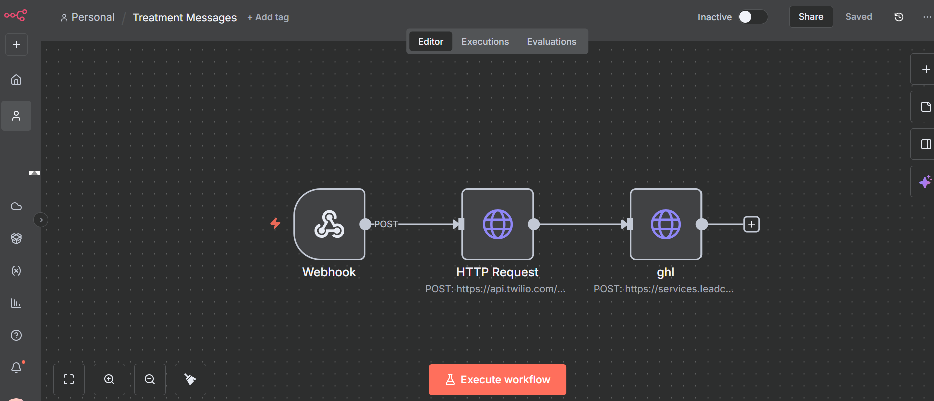
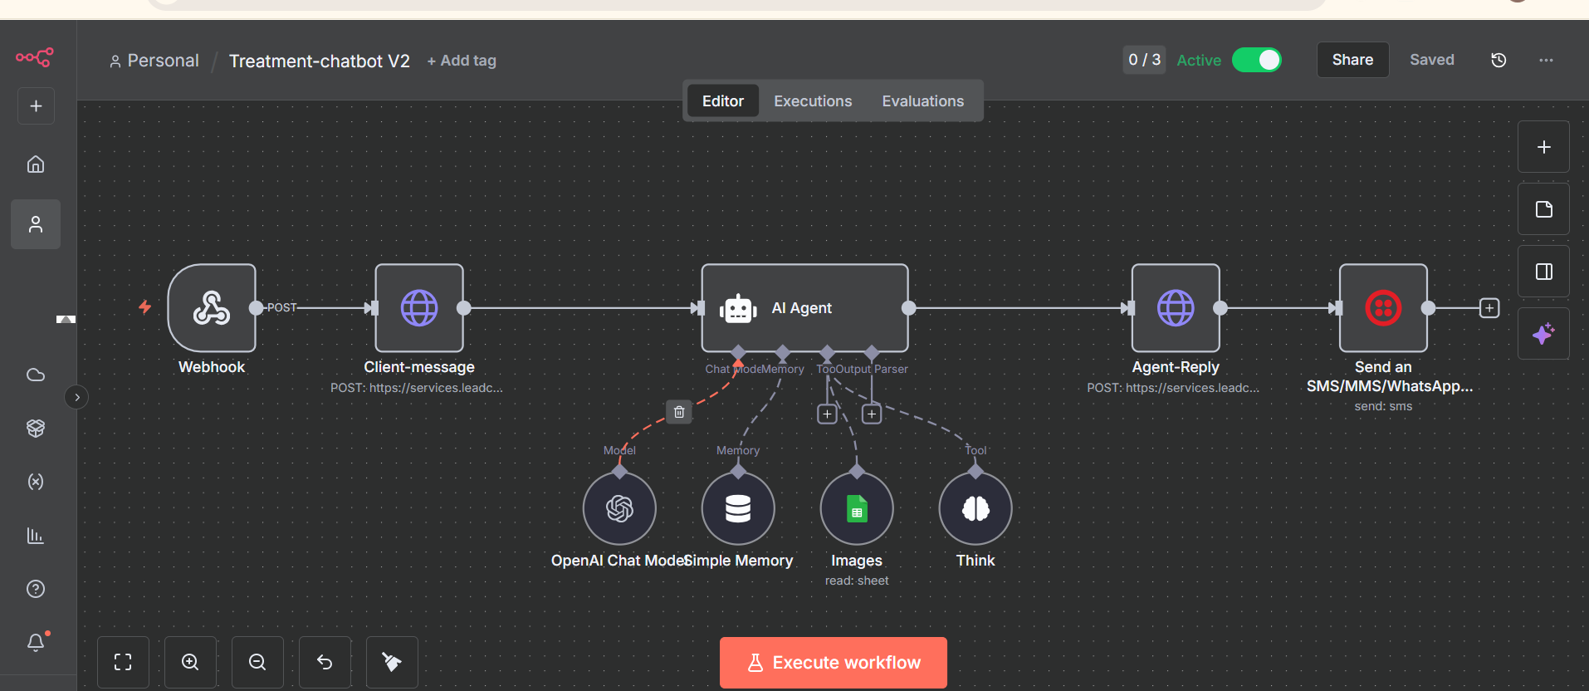
Built a chatbot for a skin treatment clinic to handle leads coming from Facebook Ads and GoHighLevel.
The chatbot responds to new and existing leads, answers common treatment and pricing questions, qualifies prospects, and guides them toward appointment booking or course enrollment.

Client Challenges
The clinic was dealing with:
• Delayed responses to new leads
• Missed follow up opportunities
• Repetitive treatment and pricing questions
• Poor quality chatbot conversations
• Inconsistent handling of course inquiries
• Difficulty maintaining accurate service information

Solution
I connected the chatbot with GoHighLevel to manage the lead journey from first message to booking.
The system:
• Responds to Facebook Ads leads automatically
• Handles leads already stored in the CRM
• Answers treatment and pricing questions
• Qualifies leads based on their requirements
• Handles appointment scheduling and follow ups
• Manages course related inquiries
• Uses conversation context to provide relevant responses
• Routes leads through the appropriate booking workflow

Tools & Technologies
• GoHighLevel
• Facebook Ads
• CRM workflows
• Chatbot
• Custom conversation logic
• Lead routing and booking workflows

Result
The system gave the clinic a faster and more consistent way to handle incoming leads, reduced repetitive work for staff, and helped move qualified prospects from initial conversation to appointment booking.
The chatbot now works as the clinic’s first point of contact, while the team remains involved when human assistance is needed.

